Bilkent University

Department of Computer Engineering

CS 319 – Object Oriented Software Engineering

*CS 319 Project: Catch the Deadline*

Final Report

**GROUP 2D**

Argert Boja, Bikem Çamli, Hareem Larik, Umut Ak

Course Instructor: Bora Güngören Progress/Final Report

Design Draft Report October 21, 2017

This report is submitted to the Moodle in partial fulfillment of the requirements of the Object Oriented Software Engineering Project, course CS319

Contents

1. Changes in the Implementation 3

2. Status of the Project 3

3. User’s guide 3

# Changes in the project

* 1. Changes in implementation
  2. Changes in UI
  3. Changes in Database

# Status of the Project

Uptill now we implemented the classes we mentioned in analysis and design reports. We have made some changes to the implementation.

# User’s guide

## System Requirements

Catch the deadline implemented in the Java platform. Therefore, to play the game an operating system that supports JRE such as Windows, MacOS, Linux and Polaris. Additionally, the updated version of Java (Java 8) and JDK will be required to run the game.

**Minimum System Requirements:**

* Java is compatible with Windows 7, 8, 10 and Windows server 2008, 2012 Mac OS X 10.8.3+, 10.9+
* A 128 MB RAM is needed
* A 124 MB Disk space is needed for JRE ( Java Runtime Environments)
* A 2 MB disk space needed for Java Update
* The computer should have a minimum Pentium 2 266 MHz CPU

## Installation

For the installation, the rar file of our game exist in our GitHub page. Therefore, the user can install the game and run the jar and executable files from any Java environment.

## Overview of the game

“Catch the Deadline” is a 2D arcade-style platformer game. Player can start the game with hitting the Play button on the main page. The player can control the student character to collect power-ups, weapons and finish the game to catching the deadline. Player has three lives he can lose these lives in several ways. Firstly, if player run out of food or sleep stocks a live will be lost immediately. Secondly, if the user fails while he/she fighting with the enemy, the level is ended and one of the lives is lost. The aim of the player is to finish all of the levels as quicker as possible to get the highest score.

## Game Objects Management System

3.4.1. Controls

* Up Arrow: Jump
* Left Arrow: Run left
* Right Arrow: Run right
* A: Attack with weapon
* S: Attack with weapon
* D: Attack with weapon
* Space: Jump

3.4.1.Objects

* + Homework: It is an enemy.
  + Exam: It is an enemy.
  + Pen: It is a weapon to shoot the enemies.
  + Eraser: It is a weapon to shoot the enemies.
  + PaintSplash: It is a weapon to shoot the enemies.
  + BlankSeet: It is an enemy.
  + Sleep: It is a power-up. However, if user will be out out of sleep one live will be lost.
  + Food: It is a power-up. However, if user will be out out of sleep one live will be lost.
  + Coin: It is a power-up. User can collect these and improve their weapons

## Game Screens

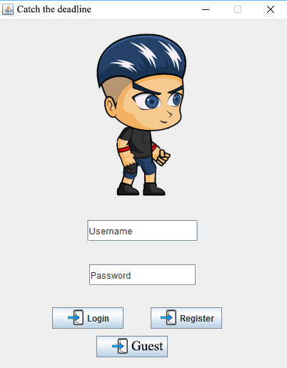Login Screen:

The login screen of the game. The player choose to be login or play as a guest options to play the game.

**GamePlay Screen:**

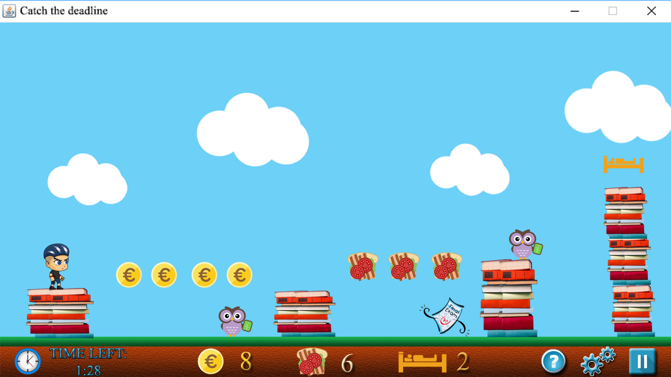

After the player pushes the play button the gameplay screen will be appear. In our gameplay screen there is coins to collect and use to improve the weapons. Foods and sleeps are the other weapons. User can go to the setting, pause game and help screens by pushing the buttons at the bottom right corner.

**Choose Level Screen:** Player can choose from three difficulty levels.

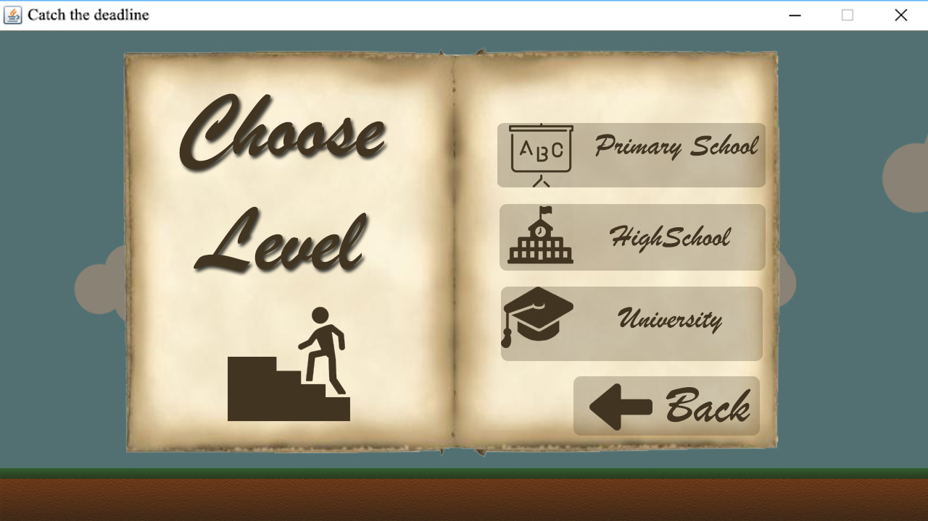

**Help Screen:** Player can use this menu to get the information about the playing process of the game.

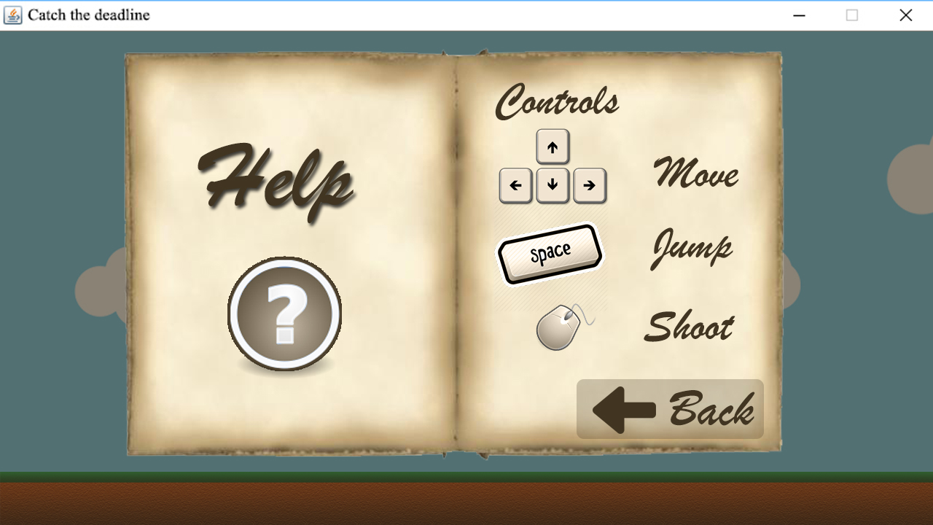

**High Score Screen:** This screen shows the highest 5 scores.

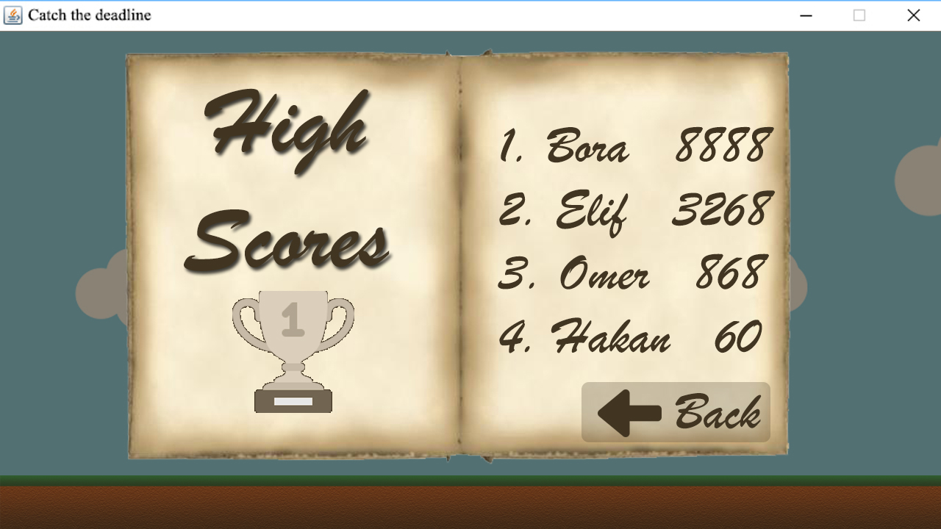

**Credits Screen:** From this screen user can see the implementers of the project.

